The bin packing problem (BPP) is a classic combinatorial optimization problem. It is known to be NP-hard, meaning that no polynomial-time algorithm is known to solve all instances of the problem optimally.

Given that our research case falls under the category of one-dimensional bin packing, we are dealing with two key dimensions: the items with varying weights and the uniform capacity of the bins. The primary objective is to allocate these items into a minimum number of bins without exceeding the capacity of any bin.

This section formalizes the problem and discusses its mathematical formulation, key concerns, and practical implications:

**Formal Mathematical Definition**

The one-dimensional bin packing problem (1D-BPP) can be formally defined as follows:

* Inputs:
  + A set of [](https://www.codecogs.com/eqnedit.php?latex=n#0) items, [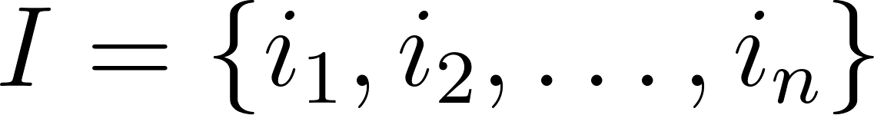](https://www.codecogs.com/eqnedit.php?latex=I%20%3D%20%5C%7B%20i_1%2C%20i_2%2C%20%5Cldots%2C%20i_n%20%5C%7D#0)
  + Each item [](https://www.codecogs.com/eqnedit.php?latex=i_j#0) has a weight [](https://www.codecogs.com/eqnedit.php?latex=w_j#0) where [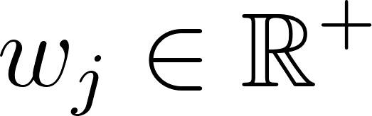](https://www.codecogs.com/eqnedit.php?latex=w_j%20%5Cin%20%5Cmathbb%7BR%7D%5E%2B#0) for [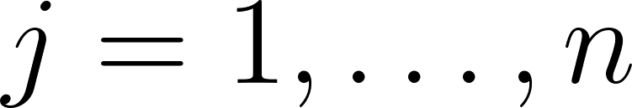](https://www.codecogs.com/eqnedit.php?latex=j%20%3D%201%2C%20%5Cldots%2C%20n#0)
  + A bin capacity [](https://www.codecogs.com/eqnedit.php?latex=C%20%5Cin%20%5Cmathbb%7BR%7D%5E%2B#0)
* Output:
  + A partition of [](https://www.codecogs.com/eqnedit.php?latex=I#0) into [](https://www.codecogs.com/eqnedit.php?latex=m#0) subsets (bins) [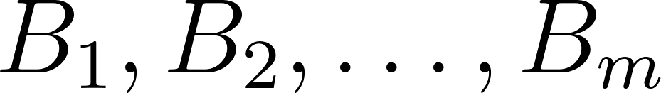](https://www.codecogs.com/eqnedit.php?latex=B_1%2C%20B_2%2C%20%5Cldots%2C%20B_m#0) such that [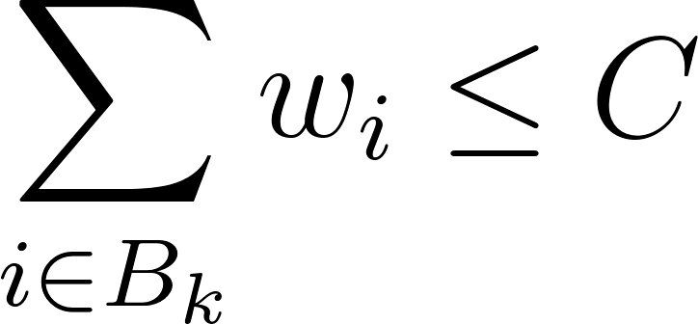](https://www.codecogs.com/eqnedit.php?latex=%5Csum_%7Bi%20%5Cin%20B_k%7D%20w_i%20%5Cleq%20C#0) for all [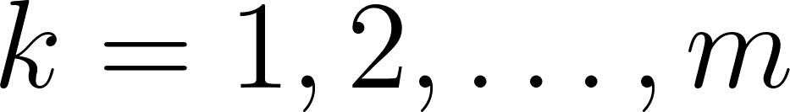](https://www.codecogs.com/eqnedit.php?latex=k%20%3D%201%2C%202%2C%20%5Cldots%2C%20m#0), and [](https://www.codecogs.com/eqnedit.php?latex=m#0) is minimized.

**Objective function**

The objective is to minimize the number of bins [](https://www.codecogs.com/eqnedit.php?latex=m#0). Formally, we can write the objective function as: min [](https://www.codecogs.com/eqnedit.php?latex=m#0). Subject to constraints:

[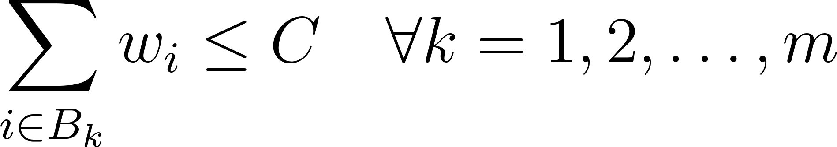](https://www.codecogs.com/eqnedit.php?latex=%5Csum_%7Bi%20%5Cin%20B_k%7D%20w_i%20%5Cleq%20C%20%5Cquad%20%5Cforall%20k%20%3D%201%2C%202%2C%20%5Cldots%2C%20m#0)

**Decision version**

A related decision problem asks whether a given set of items can be packed into a fixed number of bins [](https://www.codecogs.com/eqnedit.php?latex=C#0). This can be stated as: without exceeding the bin capacity . This can be stated as:

* Given: A set of items with weights [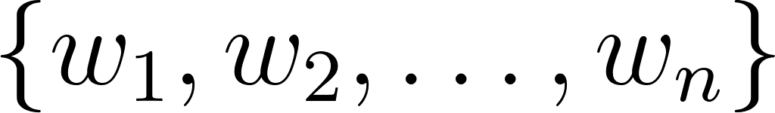](https://www.codecogs.com/eqnedit.php?latex=%5C%7B%20w_1%2C%20w_2%2C%20%5Cldots%2C%20w_n%20%5C%7D#0), a bin capacity [](https://www.codecogs.com/eqnedit.php?latex=C#0), and an integer [](https://www.codecogs.com/eqnedit.php?latex=m#0)., a bin capacity , and an integer .
* Question: Can the items be packed into [](https://www.codecogs.com/eqnedit.php?latex=m#0) or fewer bins of capacity [](https://www.codecogs.com/eqnedit.php?latex=C#0)? or fewer bins of capacity ?

By clearly defining the 1D-BPP, its formalism, and the practical concerns, we establish a foundation upon which further discussions on solution approaches, algorithm performance, and real-world applications can be built. This provides a comprehensive understanding of the problem's significance and the challenges involved in addressing it.

| Latex Code |
| --- |
| **\section{Formal Mathematical Definition}**  The one-dimensional bin packing problem (1D-BPP) can be formally defined as follows:  \begin{itemize}  \item \textbf{Input:}  \begin{itemize}  \item A set of $$n$$ items, $$I = \{ i_1, i_2, \ldots, i_n \}$$.  \item Each item $$i_j$$ has a weight $$w_j$$ where $$w_j \in \mathbb{R}^+$$ for $$j = 1, \ldots, n$$.  \item A bin capacity $$C \in \mathbb{R}^+$$.  \end{itemize}  \item \textbf{Output:}  \begin{itemize}  \item A partition of $$I$$ into $$m$$ subsets (bins) $$B_1, B_2, \ldots, B_m$$ such that $$\sum_{i \in B_k} w_i \leq C$$ for all $$k = 1, 2, \ldots, m$$, and $$m$$ is minimized.  \end{itemize}  \end{itemize}  **\section{Objective Function}**  The objective is to minimize the number of bins $$m$$. Formally, we can write the objective function as: $$\min m $$  subject to the constraints:  $$  \sum_{i \in B_k} w_i \leq C \quad \forall k = 1, 2, \ldots, m  $$  **\section{Decision Version}**  A related decision problem asks whether a given set of items can be packed into a fixed number of bins $$m$$ without exceeding the bin capacity $$C$$. This can be stated as:  \begin{itemize}  \item \textbf{Given:} A set of items with weights $$\{ w_1, w_2, \ldots, w_n \}$$, a bin capacity $$C$$, and an integer $$m$$.  \item \textbf{Question:} Can the items be packed into $$m$$ or fewer bins of capacity $$C$$?  \end{itemize} |